Local Business
Doctors, Electrician, Plumber, cleaning companies, lawyers, contractors, solar, artificial Grass, Hvac, Beauty Salon, spas, dentin, car
Types:
- Service business
- service + Products
Google Update effect
No, just one in a whole year in rare case
Earning models
- Client side
- Pay Per call (Pay per lead), (Lead Gen) - lead gen networks pr sale krty hain
- Rank n rent
Lead Sell Websites
https://leadsmartinc.com
https://www.ringba.com

Pillars of local SEO
- Prominence ( means business ko branding kr rhy hain ) (like daraz, Dawlance, J., etc)
- Proximity (Location) (mtlb business ki branding kr rhy hain aik specific area mai like geo targeting)
- Relevance ( keywords)(means aik specific jaga ko target krna hota hai) ( means specific audience)
Jab client hamary pas ata hai
no SSL installed
Keywords research issues
no social media accounts
no address, phone, contact us, disclaimer, privacy policy
no blogs create
no gud Ui/Ux
loading speed
Keywords research
- Kw ki variations nikalna sb sy pehly
- kch ko hum onpage mai laaty hian or remaining kw ko off page mia include krty haain
- hum home page pr or services page pr different kw target kr rhy hoty
Steps
- sb sy pehly variations
- phir site ka content dekhna hia or read krna hia or wahan sy nikalny hain keywords
- apna main keyword utha kr google mai ja kr apny competitors ko overview krna hai or keywords nikalny hain , just serp sy hi
- ab tools pr jaen gy, semrush pr ja kr apna keyword put krna hai or keywords nikal leny hain
Boly to
- Variations
- content
- competitors
- tools
Rules
- is mai hum site to site keyword research ni krty hoty
- is mai keyword to keyword research krni hoti hai
Content Keyword Strategy
homepage pr mai 03 keywords lagata hon or baqi ko off page mai ly jata hon.
or han varaitons ko hum 2sra kw ni smjhen gy (mtlb ignore krna hai) lakin agr variation ka search volume different ho to us kw ko hum seperate consider kren gy
mai apny un kw ko SEO title mai zror dalta hon jin ka volume zyada ho (or mai khayal krta hon k mera kw exact same aa jai beshak us mai chez repeat ho jai)
SEO Title
SEO title under 60 characters ka hona chahye
jin ka volume zyada ho mai unhen seo titlle mai include krta hon
Meta description
is mai variation add kr deta hon main kw ki
SEO tile or meta mai use hony waly keyword hum count mai ni laaty, hum H1 sy consider kren gy
SEO title mai use hony waly keyword ko hum same as it aik dafa H1 k necchy use kr len or aik bar end mai kahen
500 words mai 3 bar primary, 2 bar secondary or aik bar tertiary keyword use krna hai
agr 1000 words ka ho ga, to main 6 or sec 4 or tertiary 2
Agr client khud content dy to thek hai lakin agr hamen content likhny ka kahy to (Sementic SEO ka khayal rakhna hai)
Semantic SEO ( is mai aisy hai k apple aik khany wala or aik chalany wla hota hia us ka difference, entities use krni hai)
Image alt text
10 images mai sy 5 pr keyword ya related keyword put krna hai, remaing 5 mai brand name ya phir us image ka description
Internal links
500 words mai sy 2 banay hain,
600-700 ka to us mai 3 bhi add kr skty hain
jis page ka kw ho usi k name pr dosri page ko link ni krna
URL structure
url ko clean rakhna hai, keyword aana chahye edhar
https://astra-management.ca/Services/renovation/
https://astra-management.ca/Services/remodeling/
boht bar aisa hota hai k client ki sites k url mai kw ni hoty, aisy koe numbers ya kch otptang likha hota hai, un ko sae krna hia, aisa krny pr 404 ae ga lakin us ka solution ye hai k usy 301 kr den gy mtlb redirect
CLients sites: ye client ki site ki rooh hoti hain
90% clients site mai
- SSL (secure) ye ni hota
- NAP (Name, address, phone number)
NAP jo website pr hota hia wahi GMB mai use hota hai or wahi citations pr use hota hai
Important things (boly to must)
Yellow pages, yelp, clutch,thumbtack, angies list etc (ye hain citations/business directories/listicals)
- Pages
- About us (brand history, story)
- Contact US ( Contact form, phone number, email)
- Map embed (footer) (is ka tareeka video mai mojood hai)
Less important
- Team (social media...)
- Privacy policy
- Terms
- Feedback
- Real photos service ( is sy conversion brh jati hai)
SEO title
Primary keyword | Secondary keyword

agr aap ko client kahy k ni ye wala primary rakho to us sorat mai hum apny primary ko sec mia rakhen gy

Meta description
Variation of primary keyword + Variation of secondary keyword

H1
Primary keyword ( ya ) primary keyword ki variation jo meta description mai hum ny abhi tk use na kea ho

H2
Secondary keyword ( sirf kw hi ni blky aagy pechy koe content bhi ho skta hai )

H3
Tertiary kw

Primary (3 dafa) ( h1, h1 k nechy , last mai)
Secondary (2 dafa) ( H2, content)
Tertiary (1 dafa H3 mai ) ya content mai kahen, agr content 500 plus like 600 ho gya to aap 2 dafa use kr skty hain

Keyword stuffing
500 words mai zrorat sy zyda Primary keyword put kr dya

agr hamary pas content zyada ho to hum us mai mazeed kw bhi use kr skty hain (mtlb jo hum ny offpage k lye rakhy hoe wo waly)

hum content kw pr ni likty blky topic pr likhty hain
google entities ko hamary content mai dekhna chahye ga, q k ye relevant hon ga hamary topic sy

schema mai hamesha wo chez hi dalni hia jo hamary page pr ho, change ni hona chahye

Geo Targetting
Address,
zip code,
area code of phone number,
gmb,
maps embed,
geo tagged images( is ka mtlb hai k jo images hon gi us mai hum location add kren gy through coordinates)
longitude ( negative - mai hota hai )
Hum GMB ki images mai bhi ye wali images use kren gy mtlb us mai bhi longitude and latidue dalen gy

tool.geoimgr.com
calgary longitude and latitude (ye hum google pr likh us jaga k coordinates google sy utha len gy)
LOGO mia bhi use kr skty no issue

upwork pr client tab tk review ni dy skta jab tk us ny payemnt na ki ho, agr aap usy reverse kr den payemtn tab bhi wo review ni dy skta, mltb kch ghanty aap ny kam kye or client ki nature achi na lagy to usy amount reverse kr do , is trah wo reveiw bhi ni dy skta
---------------------
Schema (coding ki language mai btana hota hia google ko k ye kis chez ki website hai ) (mtlb google back end ko read krta hai or hamen usi hisab sy deal krta hia)
instant schema (ye hum jab traditon seo kr rhy hoty hain to ye use krty hian)
merkel schema

agr mjhy schema ko advance level pr ly kr jana ho to mai chatgpt use krta hon
on chatgpt: Please generate a local business schema for my calgary based construction company with following details:
url:
address:
phone:
ZIp code:
Email:
Logo:
SEO title:
Meta description:
services:

ye bhi add kr skty hain, mtlb social media ko
My business social profile:
linkedin:

Images:

home page ka schema achy sy bna kr daal den to wo bhi enough hota hai site ranking k lye, otherwise aap baqi k service pages ka bhi schema daal skty

-------------------------
schema.org ( check list of schema)

single location site
homepage
services

Page hamesha 2nd click tk khul jana chahye
astra-management.ca/services/tags/multi-family-home/ (wrong)
astra-management.ca/services/multi-family-home/ (best)
astra-management.ca/multi-family-home/ (best)

Multilocation
mydomain.com/location/Gujranwala/
mydomain.com/location/Gujrat/
ya
mydomain.com/service-areas/Gujranwala/

6 locations and 6 services hon to kea krna hai
her locaiton page pr sari services ko aik sath hi target krna hia, mtlb 6 locaitons k lye 6 hi pages bnen gy

agr hum different locations add kren gy ( multi location site)
to H1 k bad 150-300 tk ka contact likhna hai,
H2 k nechy bhi 200-300
h3 ka bhi 200-300

location ka URL hum just locaitn ka nam ya phir jo main kw hai jis ka volume zyada hai us k sath location add kr k bhi bna skty ahin
mydomain.com/locaiton/tree-removal-gujrat/

in ka SEO title
Tree removal, Trimming, Grinding, Lot Cleanign gujrat
ya phir
hum just first 2 main kw ko just target kr len
Tree removal gujrat | tree trimming Gujrat

Meta description ko bhi seo title ki trah generate kr skty ahin

or agr multiple locaitons ka volume bilkul hi low ho to multiple locations ko aik hi page pr hum cover kr skty hain

agr ksi city ya cities ka volume na hony k braber ho to usy aik hi page pr cover kr skty hain
Local SEO content Planning +Local SEO Home design

$300-2000 k client hoty hain, ye phir niche pr bhi depend kry ga, like plumber aik chota client hai lakin agr doctor hia to wo bra client hai, chota aap ko weekly 100 200 dy skta hia

agr cleint kehta k content or design aap log bnaen to hum ye sb kren gy, or same ye chezen agr hum apni site bnany mai bethen gy to yahi use kren gy

water damage restoration (ye aik high competitive niche hai)
search: water damage restoration los angles

open the new excel sheet, pick the all headings one by one competitors through detail seo extension and put the sheet, mai waisy top k 7 competitors pick krta hon

hum sheet open kr len gy or sb ki heading copy kr len gy, top k 7 pick kr lena

- Top rated water damage restoration los angles
- #1 water damage restoration los angles
- most trusted water damage restoration los angles
- highly reviewd water damage restoration los angles
- highest rated water damage restoration los angles

ye variation hain jo competitor sy different ho skti hain jo hum alag dikhny k lye use kren gy

3 4 parts hain website mai
Our story
Why choose us
Our services

0.4 ya 0.5 bar kw use kr skty hain

sb k under hum ny apna main kw ni dalna

FAQ's hum PAA (people ask google sy), searchresponse.io, Answer the public sy uthaty hain

rochestercleaningpros.com (student site)

Chatgpt: (hum kw research sy start krty hain)
What should be the keywords targeted for a construction company in calgary
Please give me semantic keywords for these search terms. (ye waly hamary relevance create krty hain)

hum jitny bhi heading bna chuky hon gy wo phir chatgpt ko dy kr ye kahen gy
Please use this data to give me the structure and outline for my homepage of a water damage restoration site, operating in los angelas

---------------
all heading for all competitors pu
- these are the headings from my competitors’ content, i am creating the homepage content outline for my water damage restoration company in LA, please use this data to give me a proper outline for my homepage.
- Please combine both the structures the first that you gave and the 2nd one, remove anything duplicate
- give me high ctr seo title and meta descriptions
- Please write 200 words of humanized, unique and highly converting content, tone should be engaging, it shouldn’t be duplicate, flowing correctly and below i have given you some entities, only use the appropriate ones naturally in the content

client ki site pr hum writer sy likhwaen gy, apni site pr beshak khud likh len

appropriate kehna hai jab semantic kw utha kr chatgpt ko do
site structure
- Top Bar ( phone number, email, social proofs)
- Navigation (Home, serivces, locations, Gallery, About us, contact us, Team(if possible or client site), Blog(agr client ka blog ho to usy bhi add krna hia, apni site pr to lazmi bnana hota hai), More ka button(privacy policy, term and condition, feedback, disclaimer), Logo(apni site pr must ni hota, client ki site pr hota hai),
- Hero section ( ye rank krny k lye hota hai portion)(client ko convince krny wala hota hai, Form bhi dya jata hai) ( apni site bnaty waqt fake reviews ni dalny)
- USPs (unique selling points)( aisy kon sy points hai jo hamen apny competitors sy different krty hain
- Main body ( Main value preposition)
- Our story, why choose us, benefits) ( is mai entites dali hoti hain)
- our services
- case studies
- awards/featured on: ( ye bhi apni site bnaty waqt ni dalny) (awards ki jaga featured on add kr skty hain, like featured on google, BBB, Yelp, Yellow, Trustpilot)
- testimonials ( apni site pr ye ni deny)
- FAQ's
- address
- Maps

What are the usps for this business ( ye chatgpt sy 2 3 utha kr site pr laga skty hain)
Images hum Youtube videos sy utha leni hain, ya Ai sy achi c banwa kr use kr skty hain

apni sites pr kch section hum nikal len gy
testinomial , awards, reviews ye cheze nikal len gy, featured on rehny dena hai
General Pay per call session
- Leadgen
- pay per call
networks (leadsmartinc.com, inquirly.com, marketcall.com)
offervault mia bhi boht network mil jaen gy

calls manage network (twilio.com)
apni sites pr GMB hum ni bnaty.

offervault.com

list of usa cities with population (un cities ko pick krna hai jahan ki awam 1 sy sady 3 lac tk ho)

rank and rent ( rank kr k ksi ko rent pr dena)
rankandrent.club ( ye estimate lagany k lye )

ya to hum in network mai apni calls sell krty hain ya phir hum apny area mai ja kr direct ksi competitor ko rent kr dety hain. ya to google sy dekhty hain ya phir GMB ya phir yellow pages mai ja kr search kren gy or ads lagy hoe logon ko dekhen gy, aisy log leads dhondh rhy hoty hain, agr hum in ko appoach kren to ye hum sy bhi len gy.
in ko hum aik hafty ki queries free mai dy dety hain. agr aik hafty ki 3 5 queries usy mil jati hain to ye faida mnd hoti hain, us k bad un sy pochty hain phir un ko kehty k kea bna then hum aagy hum queries free ni hon gi.

rankandrent.club/calculator

2 sy 3 maheny lag jaty hain rank krny mai
EMD lety hain, jo k achi bat hai, lakin lazmi ni hai.
in k lye guest post ni chahye hoti

hum kam prices wali niches sy start kren gy taky grip ho, or in mai sites bhi jaldi rank hoti hain

template jo mai khud use krta hon (kadence: lawn care (ye roofing mai, swimming pool, lawn care, water damage, tree removal, decoration)
QnA Session (GMB)

GMB
is k different names hoty hain, (Google my business, GBP, Google business page , Google business listing, Google maps listing, Local Pack)

jab hum search krty hain.
First : Sponsored
2nd: Local pack (ye Map ki listing sy uthata hia google) (is mai 3 result show hoty hain)

Types of GMBZ, address based
Single location (address added)
Multi location (hide address, service area show) (baz dafa hide krty hain address)
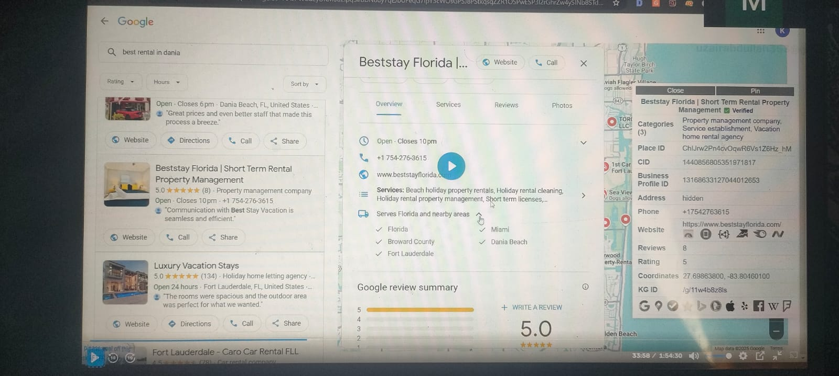
Online business ( ye address ni dety) ((aisy bhi business apna address hide kr dety hain jo ghar sy service dy rhy hoty hain, mtlb address dety hain lakin hide kr dety hain)
Some business added service area and location (yahan mai main address or service areas dono add krta hon)

Q/A
client site: jab bhi client ae ga to mtlb us ki site mai koe na koe issue hai
SEO audit (ye zrori hai) sb sy pehly
Keywords list ni hoti
keywords proper use ni hoty
Internal links ni hoty
meta titles ni hoty
Image alt tags ni lagy hoty

within 2 month noticeable improvements nzr ae gi ye client bolna hai
(q k jaisy hi on-page hamary end sy khatam hoti hai to 8-10 din site rank hona shuru ho jae gi)

agr client bahir ka ho to us sy upwork sy directly payment ly skty hain
direct contract bolty hain (is mai 5% dena pry ga)
search direct payment upwork
search: Bring your own client upwork (is mai charge ni hota)

Project catalog mai hum apni relevent hi niche dalen gy
loopnet pr commercial properties jo sale hony aati hain yahan sy bhi address pick kr skty hain , next videos mai is ka solution ho ga
upwork hamen specialized profile bna kr dosri profile bna len mtlb wo option deta hai
upwork ka cover letter hamesha solution sy ya hock sy start ho. like: ranking down hai ( to hum kahen gy kw stuffing to ni ki hoe) (deepseek use kren ye solution or hook achy bna deta hai)

Near me GMB ki waja sy rank hoty hain, ye hum contact us or about us mai use kr skty hain
GMB Setup

GMB:
Google my business, GBP, Google business page , Google business listing, Google maps listing, Local Pack

Types of GMBS, address based
Single location (address added)
Multi location (hide address, service area show)
Online business ( ye address ni dety)
SOme business added service area and location

Benefits,
Near me ( is mai show hoty)
Above local serp results (mtlb ye achi ho to is sy bhi client grab kye ja skty achy khasy)

add my business
- add or claim your business (ab business name add krna hai first mai)
business name mai ehtyat: business name exactly match website ka brand name, ya working space pr jo bil board ho same name ho,
business name mai keyword ni ghusana (agr krty hain to GMB rank ho jati lakin agr pakry gai to suspension ka samna krna prta) (agr or business kr rhy hain tab aap kr skty hain lakin koshish kren k na kren)
Edit ni krni bnanay k bad, otherwise phie sy verification krni prti hai
verification 2 trah sy hoti haim ( phone number pr code bhejta hia, pin verification( ye direct address pr bhejta hai code wo dena hota )
GMB ki ranking mai sb sy bra part business catagory ka hota hai

2 type of catagories ( ye ranking mai main role ada krta hai) (or ehm hoti hai) (category bilkul sae select krni hai) ()
primary category (competitors sy match kry ye category otherwise competitor wali line mai rank ni kr skty)
secondary category (is mai milti julti add kr lety hain)

GMB everywhere chrome extension use krni hai
is mai jis k sath star laga ho ga wo primary category ho gi

Description mai koshish ki jye ga k aik bar apna keyword use kr len

Images : ye agr original mil jaen to best hai (is mai hum GEO tagging kren gy, mtlb coordinates add krni ho gi)

hum ko GMB client ki traf created milen gi, hum unhen edit kren gy
Edit profile:
- business profile: is ko change ni krna , agr necessary hai to or bat hai otherwise ni krna
- Primary keyword: primary k bad baqi ki categories hbi add kr len gy
2nd, third ,4th and so on
- Description : 750 characters mai koshish ki jye ga k aik bar apna keyword use kr len (is ko likh bhi skty hian ya pick bhi krskty hain meta description sy baqi rephrase kr len gy to achi bat hai)
- Openning date: mtlb hamara business kab start hoa tha
- Phone number: agr ye already add ho to agr change krty hain to wo bhi phir reverify krna prta hai
- Chat: is mai hum whatsapp bhi add kr skty hain (ye time to time change hoty rehty hain hamen us hisab sy adopt kr lena hai)
- Social Profiles: is mai hum business ki bhi add kr skty hain or apni bhi add kr skty hain is sy bhi fiada hota
- Menu or servies link: mtlb yahan hum apni services k page bhi add kr slty hain boly to links
- Service areas: is mai hum wahi honi chahye jahan pr client hamara service dy rha ho (up to 20 add kr skty hain)
- Q & A: business k bary mai edhar Faq zror add krny hain, edhar wo bhi questions hoty hain jo log poch rhy hoty hain
- Update: Jo hum GMB pr article dalty hain to wo yahan dalen gy (500 k 1000 words tk ka article dal skty hain)

GMB mai hamesha products, in ki services, in k services area zror add krny hain wrna rank ni ho gi GMB
GMB everywhere extension
preper seo extension
Local Off-page pt 1
off-page SEO precautions

Low spam score less than 10%, ( baqi agr 20, 30 tk majbori k waqt ja skty hian or wahan links bna skty hain) (30% spam scor sy uper kabhi mat jana)
Bad Neighborhoods (gambling, casino, slots, betting, drugs, weapons, adult) aisi jaga pr link ni bnana jahan ye waly link hon
link farms sy bhi avoid krna hai ( google isy dislike krta hai ) (mtlb jahan without approval links ban jaty hon)
High OBLs ( outbound domains) ( refering domains zyada hon out bound doamins sy, outbound zyada ho jin ka un sy ehtyat krna hai)
Paid/Commercial sites (in sy bhi bachna hai, wo jo bs paid content dalty hon or value base apna content share ni krty)
Penalized sites sy bachna hai
Anchor text issues (number 1 issue) ( aik hi keyword pr link ni bnany ) pehly 5 ancher mai hamara keyword ni hona chahye, is mai brand name ho, naked url ho, ye waly uper hony chahye
naked url mtlb, fiverr.com, https://fiverr.com, ww.fiverr.com
empty achors bhi hony chaye (ye akser images pr bhi link mily hoty hain wo empty hoty hain) EMD mia koshihs kren k naked url uper ho
Same type of backlinks na hon blky mixture hon ( sary forums hi na bna lena)

Local SEO off-page
ye wo hain jo bnany hoty hain
Foundational nandla links (ye no.1 hain) (is mai hum kw use ni kr rhy hoty) is sy base bnti hai (this website, that website, learn more)
local business citations (ranking ki Root yahi hoti hain ye business ko rank krny mai madad dety hain is k baghire rank hona mushkil hota hai)

ye chezen zrorat hoti hain jab hum citations pr listing kr rhy hoty hain. ye her jaga same honi chahye
NAP (Name, address. phone number)
Business description
opening closing hours
logo
URL

Brightlocal, yest.com
ye citations mai hamen add kr dety hain

Local business citations types:
- Major citations: GMB, apple, maps, yelp, clutch, yellow pages, angies list, bbb, trustpilot, foursquare etc (is sy boht faida ho ga)
- industry citations/catagory citations, niche citations: ye wo hoti hain jo hamary business sy related hoty hain (edhar relevance create ho gi)
- Regional citations/Location citations: ye hamary location k relevant hoty hain
- ghair zrori (in ko avoid krna hota hia)
- ( unstructured citations ) ( ye wo wali hoti hain jis mai kahen addres ka option ni hota to ksi mai number )
- Unclaimed citations ( jsi mai email verify ni hota)
- stacked citations: ye wo wali hoti hain jahan hum aik hi website bar bar add kr skty hain
Off-page SEO pt 2
For portfolio:
Ranktracker ( https://www.link-assistant.com/rank-tracker/)
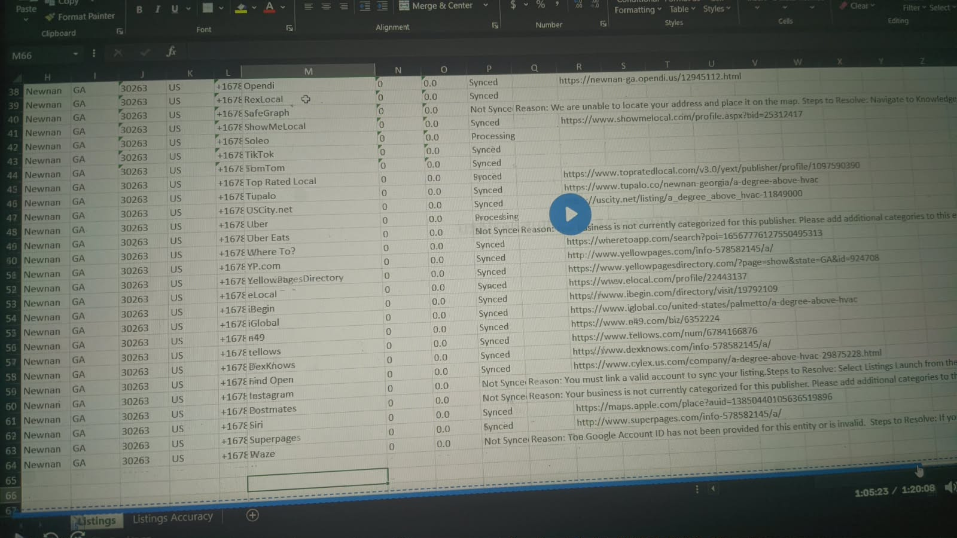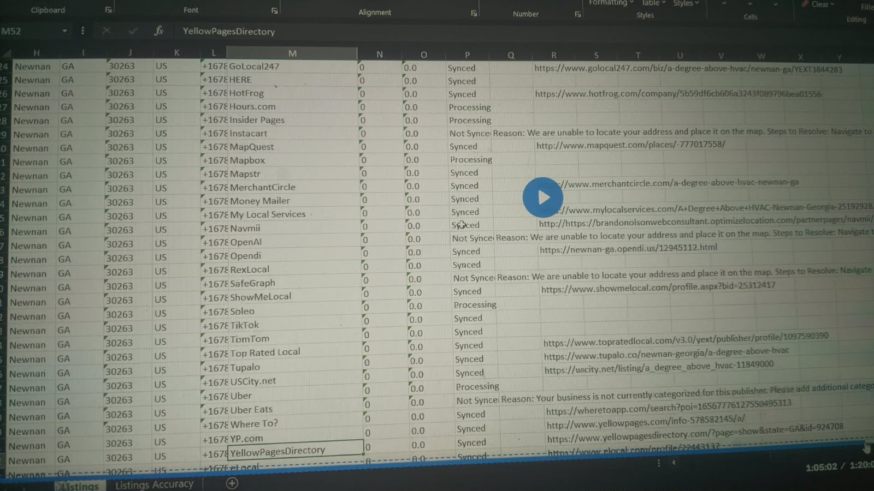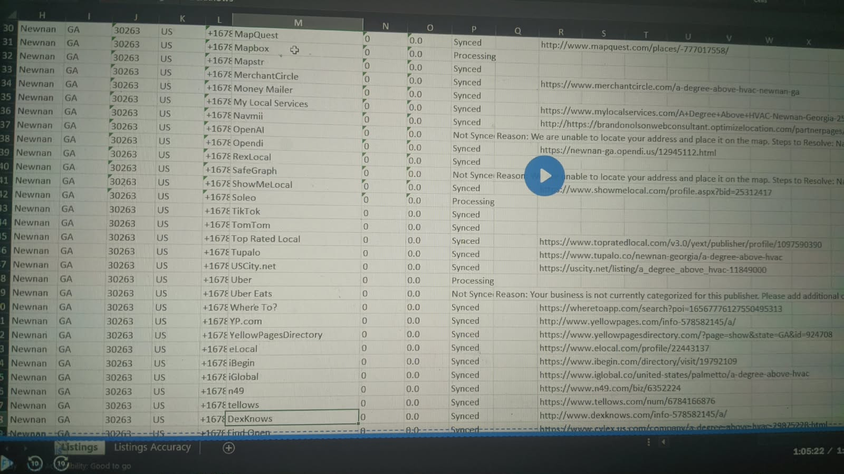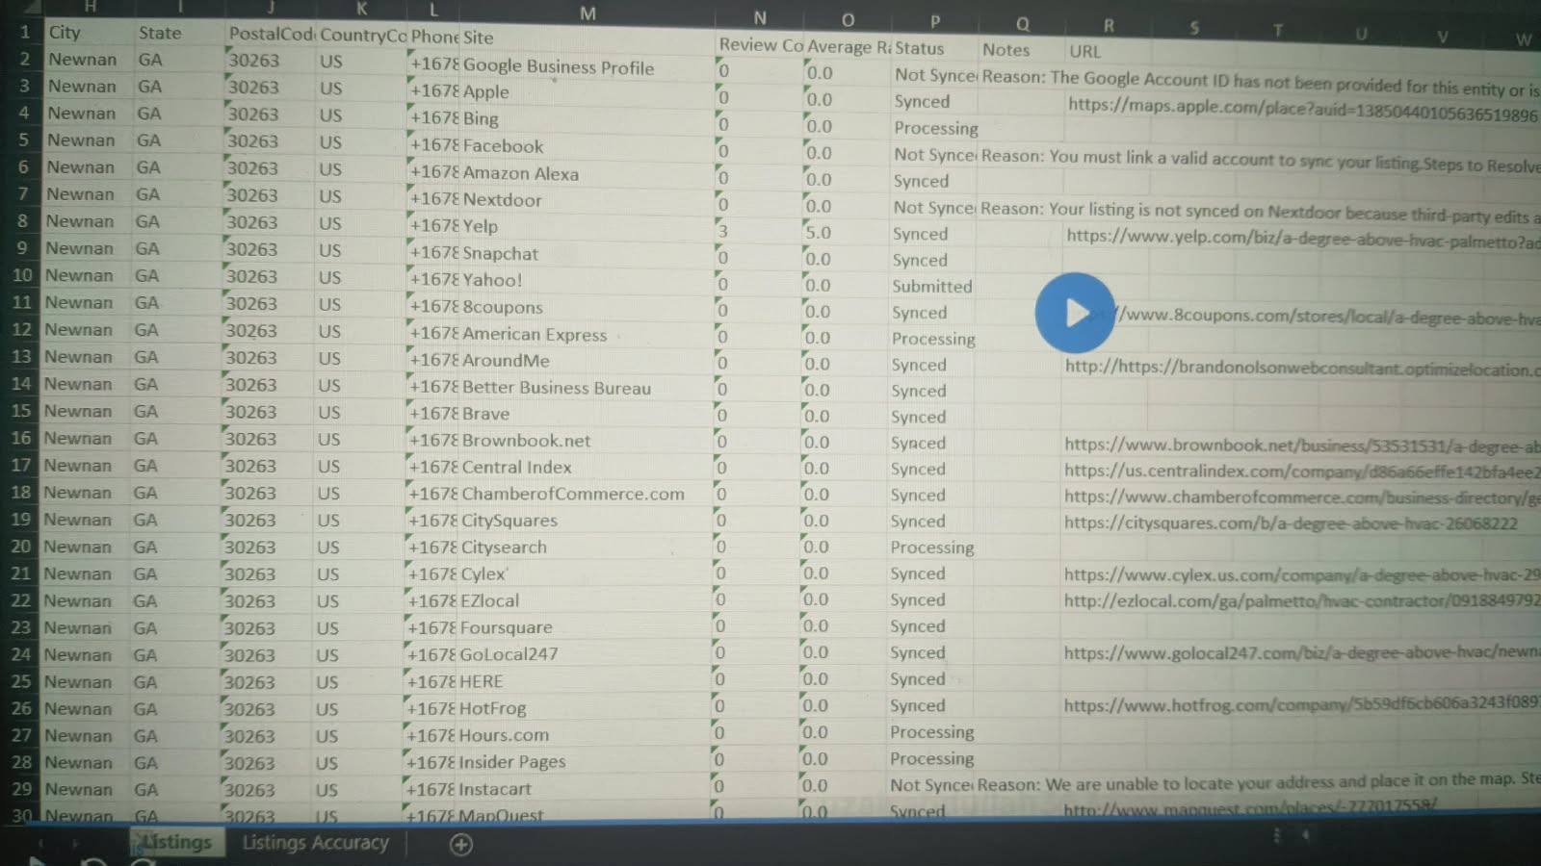

How to find local citations:
local citations list search google
( brightlocal.com "ye boht bra tool hai, edhar achi citations hoti hain""is mai countries k mutabiq list provide ki hoti hai" "in ko general listing kehty hain/major listing"

ab hum niche sy related dhondhy k lye ( dropmylink.com)
construction + "add business"
construction + "add my business"
Dropmylink pr jaen catagory resource pages select kren or apni niche put kr den
construction + "submit site"
inurl:submit-listing "construction"
jin directories ka DA acha ho ya traffic acho ho to wahan listing krni hai (1000+ traffic, tools ki traffic 500 ho to smjho k wo 1000 hai)
inurl:business-directory "construction"
inurl:submit-listing "Tampa"
inurl:business-directory "Tampa"
links:https://www.wilentz,com/
whitespark.ca ( for directories but paid)
allintext: "competitor number" ( is sy competior ki exact listing wali sites mil jae gi

for paid service for directories ( its good)
yext.com ( mai edhar sy krwa rha hota hon) (agr aap ksi company k lye kam kr rhy hon to wo log ye use kr rhy hoty hain)
whitespark.ca
brightlocal.com

mostly hum kahen na kahen ys krwa rhy hoty hain bcz sasti prti hain
or han ye jo hum buy krty hain ye worldwide wali hoti hai, niche wise or location wise wo hamen khud find krni hoti hain or wo hum 10 niche sy 10 location sy relevant bna len to enouogh hain

Social bookmarks/social sharing links
google pr likhen social media sharing sites

First nandla links mtlb foundational links
2nd directories
3rd social media sites
4th Forum backlinks (is mia hum apny kw add kr skty hain, baqi uper walon mai hum url add kr rhy hoty hain)
5th blog
6th pdf sharing, audio, video , image sharing, cloud stacking
mostly hamari site ko niche edit ya guest post leni ki zrorat ni hoti, q k local mai zrorat ni prti, han agr site bilkul atki pri hai tab ly skty hain

Forum Backlinks, ( ye bry powerfull hoty hain)
Reason for banned
forum pr jab bhi jaen to VPN use kren, na krny ki wja sy banned hoty hain
softether, windscribe, warp vpn
Forum mai signp hamesah gory k nam wali gmail sy krna hai
1 gmail 200, 300 forums k bad gmail block mai chalen jaen gy, aisi sorat mai hum ny gmail change kr leni hai.
Forums criteria
relevent ho, DA 30+ ho,
spam score less than 30 hona chahye but priorty less than 10,
traffic more than 5000 is sy kam waly bhi chal jaen gy but traffic zyada utna acha,
jis forum pr link bna rhy hon to us ka DA hamari site k DA sy zyada ho,

Search criteria:
Construction forums "vbulletin"
jaisy hum wordpress use krty hain, aisy hi forums vbulliten, buddypress, phpbb, punbb ko use krty hain or is trah k or bhi hoty hain

After joining the forums
80% forums pr intro ka option hota hia to first us pr ja kr intro kro, phir log mjhy welcome kren gy
isi trah mai bhi kch new members ko welcome kron ga
is trah 3 4 msg chaly jaen gy hamari traf sy
phir hum apni niche search kren gy or koe discussion khol kr wahan bhi msg kr dena hai k us ki tareef mai ka acha hai ye wo,
99% forums mai aik policy mai hoti hai k aap apny comment ko 2 sy 4 din mai edit kr skty hain
bs phir us comment ko 2 sy 4 din mai wapis aa kr edit kr k us mai apna link paste kr dena hai, 99% ye wla link reh jata hai,
ye waly link ghanto mai index ho jaty hain, mtlb kafi fast hoty hain
Forums pr link stay krwany k tareeky:
- size kam kr do,
- colour change kr do,
- comma mai put kr do
- emojis mai dal do
ye sirf hum wahan pr krty hain jahan hamen dar hota hai k hum yahan sy remove na ho jaen
Relevence permeters
- site relevant ho
- thread relevant ho
- text relevant ho
in mai sy koe aik ho
Rank & Rent (1/8) ( By khuram sir) Pay per pal
Rankn Rent Niche Research

- Niche Research
- Website design
- Rank
- Rent out ()commission base, weekly, monthly , ya phir per query, ya per lead, ya phir fixed monthly

Google ads, is k lye GMB req ni hoti
LSA (Local service ads) (is mai GMB required hoti hai) (is mai ye hota hai k jab tk client convert na ho tb tk charge ni krta)

Pay per pal networks
Leadsmart
inquirly
offervault
marketcall
elocal
dopacall

hum ksi bhi network ki website pr ja kr services mai dekh skty hain niches k bary mai

Niche research
profitability ( min 150 - max jahan tk jae) ye na ho k $10 ki ly kr beth jaen
low ticket niches ( jin ki prices kam hon)
high ticket niches ( jin ki prices zyada hon)
hum is chez ko google pr search bhi kr skty hain apni niche likh kr ( google ki info mai 150 sy 300 ho to smjh jao k low ticket niche hai) like (average window cleaning job cost in usa) (isy pick ni kren gy)
(average kitchen remodeling job cost in usa) (isy pick kren gy)

Easy to rank honi chahye niches
1-Less number of reviews ( GMB)
2-DA of sites less than 10 ( mjhy 3 sy 4 sites mil jati hain serp pr to gud hain) ( ahref k 7 agr dekhen to DR less than 5 hona chahye) (as least 3 zror hon DA sy neechy)
3-Less number of backlinks and Referring domains
4-Traffic honi chahye serp ki sites pr
5-Less number of pages ( hamen competition mai wo sites chaye jis k 5 sy 6 pages hon)
6-Ui/Ux acha na ho serp mai sites ka
7-business age ( aisy business hon jin ki age show na ho rhi ho to mtlb wo new hain) (top 10 mai) (ya phir 5 aisy hon jin ki age hi na likho ho) (or agr reviews bhi 5 6 tk hon kch k to or mza aa jai)
hamara exact kw comeptitor k titles mai use hoa wa hai to mtlb unhen SEO ki awareness hai

ideal niche for competition
Less than 100 reviews in GMB
less than 10 DA 3 4 sites (at least 3 honi chahye)
google pages 5 ya 6

search volume
Low ticket niches ( search volume zyada hona chahye)( is 300+ hona chahye)
high ticket niches ( less is allowed) ( 150+ to ye chal jai gi) ( 100+ ho to bhi chal jai gi)

niches ki profitability ko check krny ka calculator
rankandrent.club

chat gpt prompt
hey buddy, iam working as a pay per call business, my niche is kitcken modeling and payout is $50 per call, search volume for the main keyword is 500, consider the related keywords too, give me the earning potential

Population
min ( one lac )
max ( 3 lac ya 3.5 )
ye limit hai city ki population ki
aik lakh or 3 lakh k mid mai rehna hai

cities with population list USA

home services sy related services deni hain, ye zyada chalti hain
seasonal niche mai kam ni krna ( like pool cleaning )

niches find sources
yp.ca (find niches)
yellowpages.ca
homeadvisor.com

Rank n Rent Niche Research Part 02
mostly on page sy rank ho jati hai (jo major mistake hoti hai wo kw stuffing hoti hain)
agr off-page kren bhi to 50 60 maheny k backlink enough ho jaty hain
Ksi bhi

bry cities mai off page zyada krni prti hai like newyork, cicago
Digital marketing in new york (is mai hamen boht zyada krni prti hai off page)

Resources of niche research
Yelp
Yellow pages
angie's list
thumbtack
home advisor
affliate networks ( leadsmart, inquirly, offervault, marketcall, dopacall, elocal)

2000 business list
https://docs.google.com/spreadsheets/d/1BvE7pfXASY_oc3theWGY17jRKNRcwAi-VWXEBaaKVXw/htmlview?gid=0#gid=0
Local business niches
https://docs.google.com/spreadsheets/d/1zaLAO8bR-5FK797y2NeYOuFQodJAs5F5R6dhe1Gd43Y/htmlview?gid=0#gid=0

tree removal
appliance repair good
artifical grass
roof repair good
pest control good

serp pr agr yelp waghaira ho to usy ignore kr len gy mtlb us ka koe masla ni

Hum jab bhi per per call or local ka kam kren gy to hum EMD len gy

niche buying
1- first hamen koshish krni hai k emd mil jai
2-na mil rhi ho to ab abbreviation use kr len gy state ka, like artificalgrasslosangelesCA.com
losangelesartificalgrass.com
3- agr is trah bhi na mily to hum city kw k start mai ly aen gy
4- agr is trah bhi availible na ho to hum .net mai ly len gy,
5- last .org is k aagy ni jana
6- artificalgrasslosangeles-ca.com is trah bhi ly skty hain agr mehngi mil rhi ho to
7- Hamesha emd hi leni hai
chahy length jitni bhi bri ho jae no issue, leni emd hi hai

thmbtack ( niches finding)
home advisor

offervault

Nationwide sy start lena hai edhar competition kam hota hai
zip code walon pr jao gy to competition zyada ho ga

hum ny koshihs krni hai k start mai 20 25 30 dollar waly payout sy start krna hai

nechy pri hoe sites ki traffic 100 150 hai to us niche pr kam kr skty hain
Niche research mai vpn use krna hota hai ( taky location united state ho)
softether, urban vpn, windscribe ,
gs location changer (is pr mai doubt hon k location krta bhi hai ya ni)

Ahref
KD 0
DR 5 in top 5
intent: local
SERP features: local pack, top ads, bottom ads
include any word: services, service
exclude: near me

agr ahref ko ly kr chalty hain to less than 5 DR ki 3 sites honi chahye
agr moz ka DA ly kr chalty hain to less than 10 ki 3 sites honi chahye

yahan sy export kr k gpt ko kahen k jin mai cities ka nam hai wo alehda kr do

us k bad kweverywhere sy volume dekh len

mai agr tree removal ko search kr rha hon ga to 250 volume tk jaon ga, mtlb jab mai bulk mai research kr rha hon ga, mtlb jab niches nikal rha hon ga
Formula
=CONCATENATE(C1," ",A1)

niches and subniches (mtlb niches ki further sub niches bhi hoti hain) like tree service ki sub niche tree removal hai
agr subniches pr acha volume mil jae to us pr kam kr skty hain (q k us ka competition kam hota hia)
--------------------------------------------------
Pay per call content writing

cities
https://docs.google.com/spreadsheets/d/1i5d9tFri6VH_MRW9f9C2npQsezRbdVPBYVJRan6jRAM/edit?gid=1271680027#gid=1271680027

Roof repaire (ye high ticket niche hai)
Pest control

simple search kea google pr apna kw
apny 10 competitor ko open kr len gy
Go to Ai

windows cleaning ko skip kr den
car wash is ko bhi chor den abhi
jo home sy related ni hain wo skip kr den
start mai aap home sy related niches pr kam kren

Nationwide pr kam krna hia, ye overall US mai chal jaen gi aap chahy jis mia bhi city mai site ko rank kren

Prompt
- Hey buddy
- you are an analyst and an expert content writer
- give me a list of words that are usually used by Ai content writers, which makes them detectable, make a search
- give me a list of prompts that will make you write killer content without Ai touch
- ( ye sb kch copy kr lena hai jo Ai ny dya )
- Ab hum apny sary competitors ki headings copy kr k save kr len gy ( total 10 competitors)
- I am a pay per call company, my niche is tree removal in dallas, who are my target audience?
- What should be the tone of my content?
- ( ab hamen ja kr sementic entities uthani hon gi ja kr "topicalrelevance.com" ya wikipedia ka page uthae or whan sy sementic entiites uthaen ( tree removal wikipedia)
- entites AI ko deni hai or phir
- These are the semantic entities, that we'll use during content writing, add them to the memory nothing else
- Hum wikipedia mai sy (google pr kw likh kr aagy wikipedia likh lena hai or us page ka url ai ko dy kr kehna k is page sy sementic entities uthar), GMB mai sy bhi entities utha skty hain ( lakin her jaga sy ni uthani taky stuffing na ho jae)
- Here are the headings from my top 10 competitors, analyze them and make an outline, that combines all their information, plus add anything that is missing and you think it should be added, goal is to achieve top rankings in google and Ai overview by beating all of them and become an authority in tree removal dallas, Also keep in mind the EEAT, NLP and local trust factors, ok?
- uper wali prompt k 7 heading shamil kr dena phir 👆
- apny related kw bhi dy skty thy hum pehly hi( top traffic waly) 👆
- These are my related keywords, keep them in memory ok?

jo ai bna kr deta hia us mai kafi kch missing hota hai jo hum khud sy add krty
extra things we use
Tools missing hai (equipment that we use)
trees falls (mtlb kitny giry hain , kitny log injured hoe hain etc) apny mtlb ka data pick kren gy

ye extra chezon ka data utha kr hum ai ko den gy or kahen gy

evaluate this data and add to my outline
is sy hum ny competitors ko to cover kea hi 7 mai hum ny extra chezen bhi cover kr li means next level

upgrade the outline accordingly ( ye gpt ko daina hai)
is ko copy kr lena hai or save kr lena hai

we'll write the content in sections, it shouldn't be duplicate, give high authority references wherever possible, use related keywords and semantic entities naturally, the sentences should be small and impactful, less than 20 words, don't use passive voice, the understanding level should be of an 8th grader, should be detailed, comprehensive and concise, no fluff, also keep in mind the list of words that should be avoided, we talked before about them. There should be flow in the sections and humanized writing style, keep an eye on the target audience and tone. Strictly follow the instructions, I'll provide you with the outline ok?

ab hum isy wahi heading den gy or content copy kr len gy

use this content to make some tables and give me their placement
(is app pr jaen gy app.napkin.ai ( ye visual allustration bna kr dy ga jo hum content mai use kr skty hain)

suggest any visuals or interactive tools, that can be used

yes please design this ........
ye jo tool sy wo hum custom html mai ja kr use kr skty hain

images youtube sy utha leni hai

-------------------------------------------

Thumbnail PPC, RnR Final

Grok
chatgpt
Claude (ye bhi acha work krta hai)

hamra home kaisa ho ga
Home | services >( tree removal, tree trimming, tree stummping, stum removal, tree care) | service area >( .......) | Our process | About | Team | Contact | Blog

agr hum single locaiton kr rha hon, to hum service area ka page add kron ga, hum jab single location cover kr rhy hoty hain to hum us ki surroundings bhi cover kr rhy hoty hain (hum service area k under list bna lety hain or us mai add kr lety hain)

Home | services | service area | our process(is k under hum explain krty hain to hum btaty hain k hum kaisy kr rhy hain tree removal) | about | team | contact | blog

ye our process her jaga pr same ni ho ga mtlb kahen our prices bhi ho skta hia like jahan doors ki bat ho rhi to wo to bna bnaya door sell kr rha hai to wo our price ho gi na.

meri suggestion k aap main niche mai jaen lakin choty city k under, q k is trah hamary pas content zyada ho ga or hum us ki base pr rank kren gy

gpt for blog: i am a tree service business in dallas, please give me a list of topics for my blog, to become an authority in my niche and dallas city, search

url structure
treeremovaldallas.com/services/stump-grinding/ is mai services ka page bnaya jaya h
treeremovaldallas.com/stump-grinding/ ye wala category hai

mai services ka page ni bnata jab k sirf catagory create krta hon.
q k google kehta hai k jitna click(url) lamba ho ga wo mery nazdeek acha ni

low ticket niches:
car washing, car detailing, window washing, carpet cleaning, barber shop, locksmith

High ticket niche
Security system, house security (ye boht high ticket niches hain)

kch niches aisi hain jin pr pay per call ni mily ga jab k rank and rent krna pry ga
offervault pr jitni bhi niches hain wo pay per call hon gi

Pay-pe-rcall:
mai 80% home sy related niches hoti hain

numbers buying
Twilio.com ye $15 ka trail deta hai
pehly hamen address chahye ho ga taky hum apra area code correctly use kr sken
loopnet.com yahan pr address mil jaty hain (zip code pr kam kr rhy ho to zip code dalna hai) (lakin jab nationwide ho gy tm to masla ni)
dallas virtual addresses (ye bhi adress utha kr hum use kr skty hain)
addresses ko just hum ny website mai use kr skty hain is k elawa in ka koe kam ni
zip code jo ho ga address ka us ka hum area code google sy nikal len gy search kr k
hum phir jo number buy krny lagen gy us ko hum google map mai check kr len gy k is pr GMB to koe ni pri
signalwire.com ( is pr hum 0.5$ mai number ly skty hain)
pictures hum facebook, youtube sy utha len high quality mai
pictures k lye zrori : remove exif data > is sy hum images k sath jo data hota hai wo remove krta hai
aisa data remove kr k phir geo tag kr k upload kr den apni site pr
bulkresizephotos.com
or video k lye aap ss lo or phir canva mai ja kr video create kr lo
is trah youtube mai video dal kr apni site pr embed kr lena hia
usi site ka baqi social profile bna len, is sy bhi edge mil jai ga aap ko

mai middle host use krta hon
baqi aap hostinger use kr skty hian no issue

jab hum apni site bnanay lagen to hum apni site ka nam or main kw ly kr grok ko den gy or kahen ka mai pay per call ki site bna rha hon to is ka mjhy navigational menu bna do mtlb structure bna do

************************
Rank & Rent ( Off-page SEO audit)

- High spam score
- below 10%, (upto 30%)
- Auto approval sites ( sy bhi bachna hai) mtlb link jaisy hi dalo to wo approve ho jae
- Bad neighbourhoods ( casino, gambling, adult, weapons, drugs, cracks, torrents
- high obl
- commercial site ( pbn, guest post sites with only link selling intent, backlink exchanges
- penalized sites (ya jin ko lagny wali ho ya lag chuki ho)
- link farms

in sy boht bachna wrna google penalty dal dy ga
jab penalty lag jai to kea krna us sb pr aaj prhna hai
mery aik client ki case study hai (thedinah.com)
jab penalty lagi to ye mery pas aya, to sb sy pehly mai ny is ka seo audit kea k is ki ON-Page seo mai kea issue hai, is k keywords ka gap dekha, on page seo pora set kea, meta title , descriptions, internal links, alt tags, ye sb resolve kea, jab mai confident ho gya k on page ok hai to phir mai off-page ki traf gya

MOZ.com
- Link explorer > put websites
- click the linking domains
- Sb sy pehly spam score dekhna hai > desending order ( jis ka zyada hai wo uper)
- Click the left bar of Spam score
- 1-30% green
- 31-60% yellow (upto 60 tk mai warning deta hon, in sy jan chura skty ho to thek hai otherwise itna issue ni)
- 61-100% ( in sy jan churwao foran)
- hamen linking domain mai ja kr wahan sy export krni hoti hai file ( wo is lye q k yahan sy hamen just domain milti hain )
disawvow file generator ( susodigital.com)
save to file
go to google and search google disawao tool
upload disavow list
- agr 1000 mai 200 ko aik 7 ni disawao krna, 40 40 ya 50 50 k badge mai kr dena thek rhy ga mtlb 20% sy start lena hai
- aisi domain jin ka spam score zyada ho ga lakin DA bhi zyada ho ga to mai usy skip kr skta hon abhi k lye jab tk mai us k jaisa acha link na bna lon
- acha DA 50+
Disavow file generator
susodigital.com

google disavow tool
then

offpage seo k lye semrush ya moz use kren gy, ahref ni

Semrush
- backlink audit
- Create project
- abc.com
- project name: abc
- select www & non-www version
- start backlink audit
- click the toxic number
- Export
- moz or semrush ki file ko combine kr lena hai
- then go to duplicate remover ( dedupelist.com)
- then go susodigital
------------------------------------------------
GMB Optimizations
Local seo wala client is k lye bhi bolta hai, ( its a big service)

De-rank issues
- Business name issues ( is mai business name as it use krna hai lakin kw use ni krna ) ( is sy rank bhi hoti hai lakin suspension bhi ho skti hai ) ( is ko change krty waqt khayal krna q k ye verify krwana pr jata hai phir )
- busiess description ya to proper add ni hoti ya phir optimize sae sy ni hoti ( is mai services, location, main kw wo bhi mention ho jae to acha ho jata hai) ye sb kch natural hona chahye ( is mai business ka overview don ga )
Business categories
- 1-primary category ( ye hamesha honi chahye ) is k baghir rank ni hoti gmb ( agr mai dentist hon to meri primary category dentist ya phir dental clinic ho skti hai, dental in plant ni ho gi q k ye aik service hai )
- 2-secondary category ( is mai service or relevant chezen aen gi)
- Services ( ye bhi missing hoti ) ( website pr jo services hain to wahi services add krni hoti hain )
- service areas agr site pr hain to wo bhi gmb mai add kren gy otherwise ni kren gy
- Products ( agr products hain site pr like wo digital hain ya phir physical koe bhech rhy hon to wo bhi add kren gy) sb ki sb
- Reviews ( ye ranking k lye boht zyada important hain ) ( or jitny bhi reviews aen un ko respond krna hota hai )
- Stock photos ( pixabay, unsplash, freepik) aisi koe bhi photo jo aap ny kahen sy uthae ho is trah ki free sites sy to wo app ki gmb mai issue krty hain yahan tk k suspend bhi ho skti hai (ye google ko btati hai k hamara business real ni hai)
- Geo taging lazmi hota hai krna (jab client pictures dy to us ko geo tagging zror krni hoti hai)
- website bhi add krni hoti hai GMB mai
- Attributes ( ye features hoty hain mtlb k humary pas parking availible hai, wheel chair availible hain etc ) ye chezen bhi add krni hoti hai
- Hours ( ye lazmi add krna hota hai )
- FAQs ( ye ya to customer khud aa kr pochta hai gmb pr ya phir aap khud add kr den ) ( is k lye people also ask, search the public ) lakin is ka tareeka is trah ho ga k aap ksi usa base gmail sy question krna hai or phir apni gmb sy usy answer krna hai )
- Bookings, Appointments ( is ko bhi use krna hai )
- Updates (ye boht important portion hai )
- 1-add Offer: ( like 10% disscount, busienss anniversary offer)
- 2-add event:
- 3- Add update: ye wo hota hai jis mai hum post krty hain like blog ( ye ranking mai acha part play krti hai ) ( is mai hum apny busiess k hawaly sy updates dalty hain like location change , ya keo bhi busiess sy related ) case study : ye boht important role play krti hai ( is sy client attract hota hai) like hum ny 5k ka claim pay kea customer ko
- Testinomials: agr koe hamara client hamari site pr review deta hai to wo bhi hum gmb mai add kr skty

- GMB mai keyword add ni krna, brand nam hona chahye jo mtlb url wala ni blky wo jo hamari site pr hamary logo ya site ka name hai, hum inehn same ni rakh skty q k google isy approve ni kry ga

- GMB Rankings ( Follow organic rankings) jab tk site rank ni ho gi to gmb bhi rank ni ho gi

chrome extensions
GMB everywhere ( ye category dikhata hai)
GMB crush
Plerper SEO ( ye percentage btata hai category ki) (ye zror ki jye ga)

jis pr star laga ho wo primary category kehlati hai
or us k bad jo ati hain wo secondary category hoti hain
one primary or upto 5 secondary category add krni hoti hai
is sy busienss relevant ho jata hai

yr orgainic ranking ko follow kr rhi hoti hain, mtlb aap ki site rank ni hai or aap chahty hain ky ye rank ho jai to ye mumkin ni, site ko organically rank krna first priority hai

******************
Session
Factors status notes
60 70% client hamen kehta hai k GMB bhi handle kro
GMB audits
- Listing verified & Live ( my busienss google pr likhny sy show ho jata hai k visible hai ya ni gmb ) ( mtlb k wo verified ni hai)
- Business name ( exactly brand name hona chahye ya jo board pr hai wo ) ( url or brand name change ho skta hai means k dono alag alag bhi ho skty hain)
- Business description:
- Address
- Phone Number ( is mai hamari koshish hoti hai k landline number add hona chahye )
- Website Link:
- Appointment Link: (
- Primary Category:
- Secondary Categories:
- Opening Date
- Operating Hours
- Payments Accepted ( ye hum website sy dekhen gy ya client sy poch len gy)
- Services added
- services areas added
- Products added
- NAP added & Complete
- Attributes Added
- call history : performance mai show hota hai
- messaging on
- cover photo ye bhi geo tag kro
- profile photo ye bhi geo tag kro
- general photos
- real photos
- geo tagged

Other Imprtant Aspects (issy hamen ye pta chalta hai k interection kitni hai,)
- Photos Quantity
- Last Photo Updated
- Total Posts
- Last Post Date
- Total Reviews
- Last review Date
- Response rate kitny logon ko mai ny response kea hoa
- Last response date
- negative reviews ( 1 2 3 star rating negative mai aati)
- % Negative Reviews Responded
- % Positive Reviews Responded
Negative fake reviews ko flag kr den, conflict of result choose kr k submit kr dena
Bounce rate kam sy kam hona chahye (speed kam, hooks ka na hona starting page pr) ye waja hoti hai bounce rate ki
--------------------------
GMB Verification

VPN overall usa ka laga den to no issue for kw research
Low DA sites hon lakin traffic na ho phir wo kw acha ni, kch na kch traffic honi chahye (aisa bhi ho skta hai brandnew site ho to us ki traffic kam ho ga to ye chez khud dekhni)

is sy hamen pta chaly ga k site wordpress pr bani hoe hai ya ni
builtwith.com
wpdetect
abc.com/wp-admin/
wpanalyzar extension

verification gmb (takreban sb clients k gmb bany hoty hain hum ny just optimize krna hota hai)
client gmb generate ka jab bolta hai to us mai sb sy ehm video verificaion hoti hai

hum purnay waqto mai ( virtual addresses ly lety thy websites sy ya phir facebook groups sy aisy log pakarty thy jo hamen addresses dy sken)

PostScanMail.com
aap ko address chahye ho to aik dafa in website sy address buy kr len or bs phir gmb mai address ki changing na kren

Craiglist ( is sy bhi buy kr skty hain )

Pay per call
- website
- NAP ( emd pr brand name ni rakhna otherwise gmb approve ni ho gi)
- Phone number ( local, signalwire) signalwire sy hi lena number because ye code sae sy accept krta hai , twillio wo verification pr ni ata( or han dekh lena k number pr already gmb na bani hoe ho, is k lye google map pr ja kr search kr k dekh len gy
- website indexed in google
- hamesha old gmail use krna, bilkul new na ho or gmail bhi usi number pr bnana hai jo website pr add krni hai( agr gmb app ki gmail pr verify na ho rhi ho to aap old account gmail ka kahen sy buy kr skty hain or wo use kr skty hain)
- apna brand nam apny content mai naturaly 5 7 dafa use kr lena
- Citations ( ye gmb sy pehly kr lena koe 20 aik taky gmb easily verify ho jai)

Website
Search console and indexation
gmail ( first the us number pr ) ni to phir old gmail buy kr len
Brand Name, phone number, address
15, 20 local citations ( index ) ( yelp, yellow pages, manta, hotfrog, merchantcircle, bing, clutch, angies list)
Brand name mention in content
Business email

Website
search concole and indexation
gamil, old gmail
brand name unique, phone number, addresss(ye buy krny ki zrorat ni hai agr phone number pr hi code aa jata hai to)
local citations
brand name mention in content
phir jab gmb hum sy aagy ja rk gmail mangy to hum busiensss email den gy usy

========================
PPC Number Creation & Setup

signa wire mai space kehty hian sub account k lye taky diff niches sae sy cover hon
or twillio mia usy sub account hi bolty hain

- signal wire
- phone numbers
- get a phone number
- select local
- enter area code
- yahan sy buy kr len gy
- then tools mai call flow builder mai jana hai
- add new
- is ka nam rakh lena hai niche k according
- handle call ka option pehly hi show ho rha hota hai bilkul middle mai
- hum ny forward to phone pr click krna hai or handle waly ko forward sy sath attach kr len gy
- is ka bad hum right side pr numbers den gy k call kis phonr number sy kis pr jae gi (formate: +12067888793)
- ye call flow free ni hoty in ki minimum sy fee hoti hai per month
- deploy krna hai jo k left side pr hota hia
- Deploy k bad hum jis jaga pr number khareeda wahan jaen gy or wahan edit ka option ho ga to us pr click kr k hum usy ye call flow assign kr den gy

Twilio ka tareeka bhi is video mai hai
edhar studios mai flows mai jaen gy after buying the number
name likhan hai
is mai call forwarding select kren gy
edhar bhi number add krny ka format same hai
then publish
is k bad jahan sy number buy kea tha wahan us number is call flow ko alagana hai

Doppcall.com ( ye bhi offers deta hai ) (ye mai kam hi use krta hon)
ringba, doppcall, inquirly, leadsmart or aisy boht sy network hain

hum jab site live kr den to hamen accounts create kr lena hai in uper wali jaisi sites pr q k wo hum sy state ni pochty, hum ny unhen kehna hai hamen calls aa rhi hain hum seo sy traffic ly rhy hain hamari calls waste na ho jaen. (q k wo states ni pochty mtlb webssite k state) kch network mang len to or bat hai (agr payout ya phir conversion sae na ho rhi ho to phir aap network change kr len gy)

daily k 20 25 clicks aa rhy hoty hain to mtlb aik 2 calls convert ho jaen gy.
Pay per call filp bhi hoti hain domaindepot pr

apna home page pr 3000 words hona chahye

domaindepot ( yahan pr site bikti hain )

PPC, Expired domains intro
niche research k times low DA ki site neechy na pri hon, agr wo uper hon gi to usy replace krna asan ho ga.

hamari sites jab hbi banen to wo highper local honi chahye
Rank krna asan ni hota lakin himmat ni harni
jaldi giveup ni krna, 2 sy adhae month zror mind mai rakhna
pehli site hamesha tang krti hai
hyper local ka mtlb jo bhi cities hoti hain us k sath choti choti jaghen hoti hai unhen, site pr location pages mai ye waly ilaqy add ho jaen gy, ye chezen outrank krny mai bra faida dety , cities, vilages jo bhi ho cover krna

Homepage, 2 service bna kr beth ni jana, blky
homepage, 2 4 service pages, 2 4 location pages, about, content, more<privicy policy, terms & condition, disclaimer (ye waly pages hum ksi bhi ai sy banwa lena hai or hana kahayal krna hai k ye content duplicate na ho or hum local k case mai hum in pages ko index krty hain)
phir hum blog ka section bnaen gy, is mai hum apni services sy related content ko target kren gy. phir hum in ko internal link kr den gy homepage pr.
hum ny jab bhi ai sy hamen plan chahye ho to hum usy ye bhi kahen gy (the goal is to outrank competitors, rank on top of google and Ai overviews) in ko ye bhi bta skty ahin k meri GMB ni hai

- i am a pay per call site, targeting tree removal services in tampa, please search the relevant market and my top 10 competitors, give me a comprehensive 2 months blog content plan, to become an authority, keep an on EEAT, NLP and semnatics, the goal is ot outrank competitors in 2 month and rank on top of google and Ai overviews, i don't have a gmb.

ai sy pochna hai k hamen kon kon sy pages bna skty ahin, jo wo kahy to wo bna lena, q k hum isi trah hi outrank kr skty hain
===============
offpage
blog2social (en.blog2social.com) (is mai kch paid hai kch free) isy kehty hain social signal

first month mai hamari site 1000 impression cross kr jani chahye,

blog2social
- social profile (branding) (Prominence) khud bnaen
- Local citations (80-120) thora thora kr k , is sy zyda bhi bna skty ahin yebhi khud bnaen
- Nandla links (ye group sy bhi ly skty hain)
- Google stack + Podcast (ye bhi group sy bnawa skty ahin)
- Web 2.0 ye bhi thory sy ly li jye ga, just 2 4 link bs
- Free guest post bhi ly skty hain lakin criteria dekh lena OBL, spam score etc
- Froum links with proper anchor

agr site phir bhi rank na kry to guest post ly len apny major kw pr. is sy top pr aa jai gi
agr chezen paid hbi krni pren to 40k tk ho ga, lakin benefit ho ga

- i am working on local business site, my main niche is kitchen remodeling tampa, please check my top 10 competitors and recommend me the service pages that i should create.

